Assignment #14 Watson Analytics Case by Joshua Troup

“What a graduation degree will fetch me?”

**What is the breakdown of Weekly Earnings by Education Level and Age Range?** (Excluding age 0-19, 70+ years old and education levels 9th-some college)

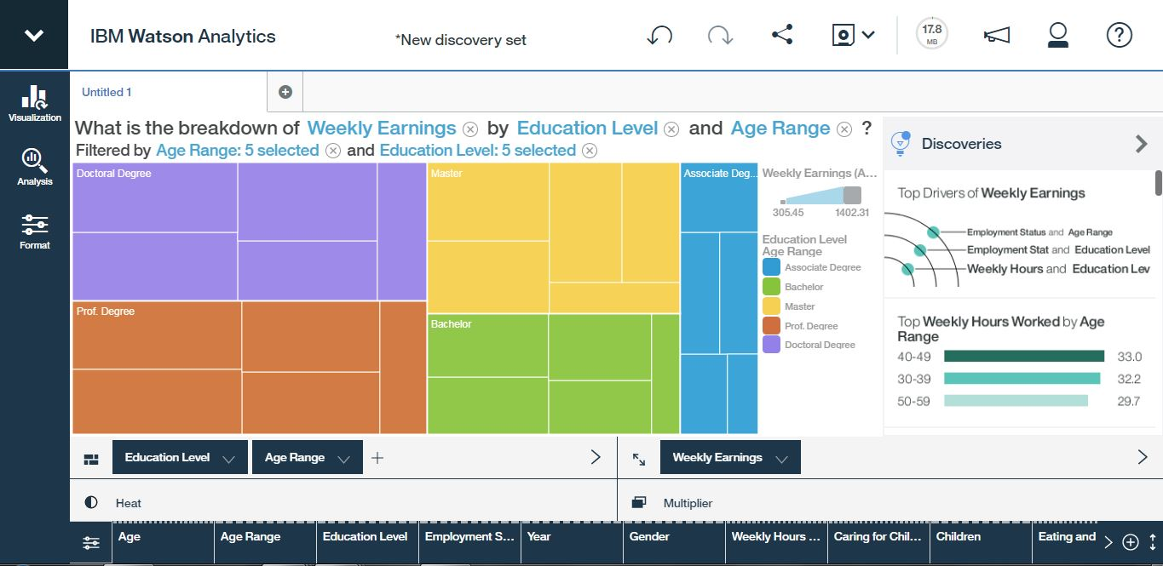

The graph above displays what one may expect in regards to education and age with weekly earnings. Higher the education level results in a higher weekly earning. The same concept is relevant for age range in regards to all the levels of education. The more years one has in an industry or increase in age, the more income they earn. Weekly hours worked seem to decrease as age increases.

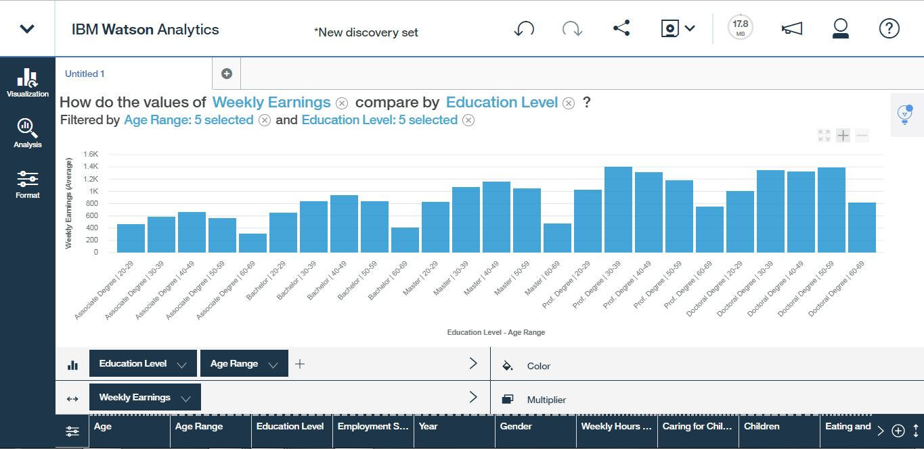 The bar graph above shows earnings reach a peak in their 30s and 40s regardless of what level of education the individual has.

**What is the breakdown of Weekly Hours Worked by Education Level?**

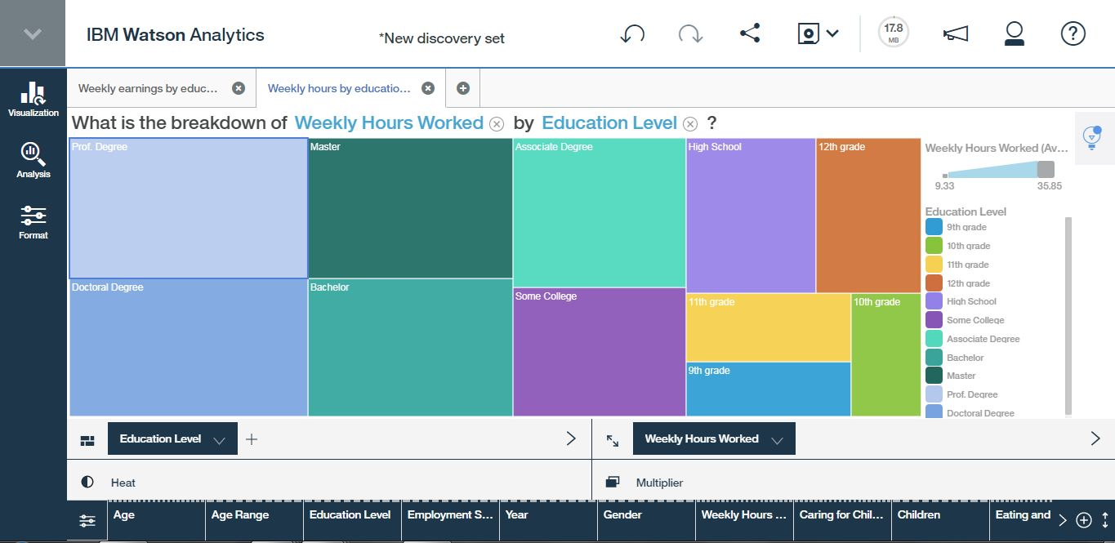

The tree map above shows people with a higher education level spend more time working more hours weekly in their career.

**What drives Weekly Earnings?**

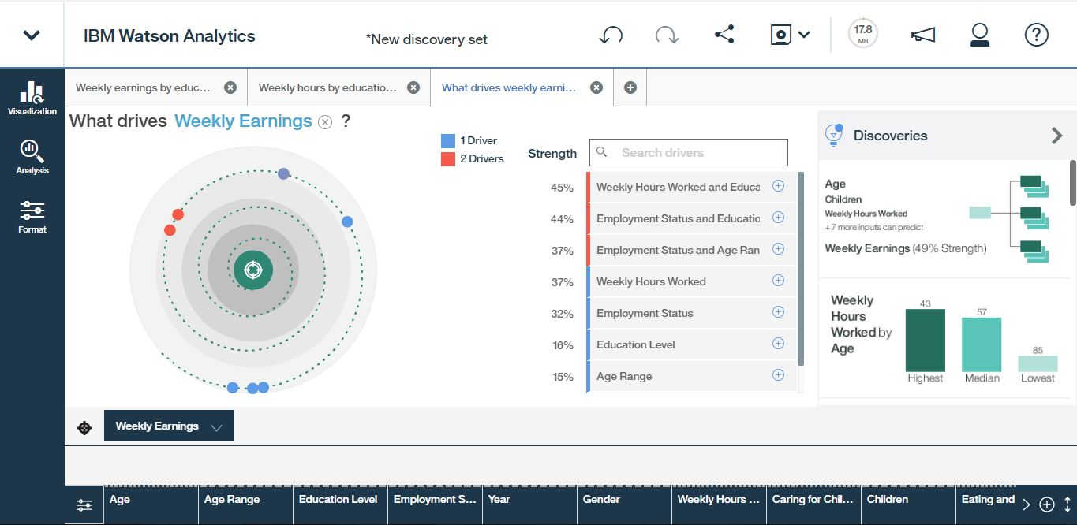

The top two factors or drivers that drives weekly earnings is in fact education level and the amount of weekly hours worked which correlates with the findings from the previous display of hours worked and education level. The next two drivers include employment status and education are also top contenders as drivers in weekly earnings.

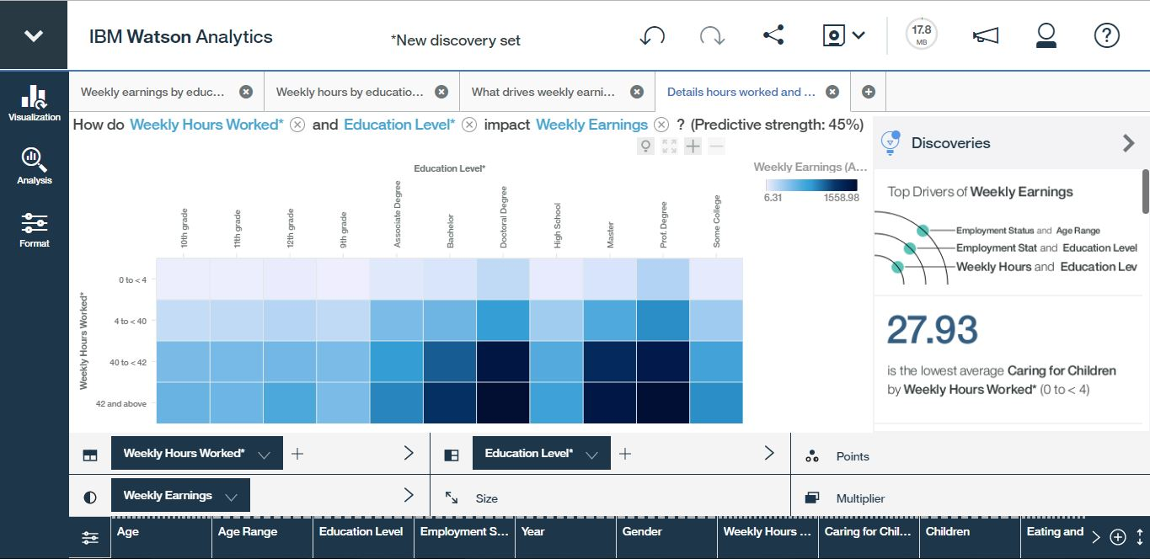

The graph above is a detailed heat map of the two common drivers hours worked weekly and education pertaining to weekly earnings. The color intensity of the heat map shows higher earnings towards the right section of the map in dark blue including bachelor, master, doctoral, and professional degrees.

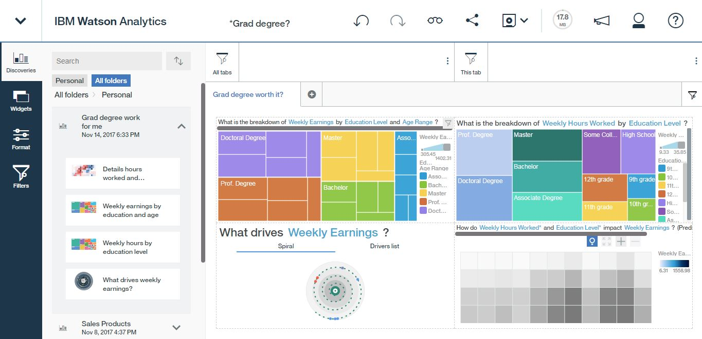

Dashboard overview of the four discoveries found in regards to “What a graduation degree will fetch me?”